**Q.3 What are the components of a MAC address? Explain with example?**

**Ans:-** A MAC address stands for Media Access Control Address, is a physical address that works at the Data Link Layer. **MAC Addresses** are unique **48-bit**hardware numbers of a computer that are embedded into a network card. The MAC address consists of two parts-

Manufacturer ID/ Block ID: This part identifies the company that made the device. It's like the brand of the device. This is the first 24 bits of mac address or contains three octs.

Device ID: This part is unique to each device made by that company. It's like the device's own personal code. This is the remaining 24 bits of mac address or last 3 octs.

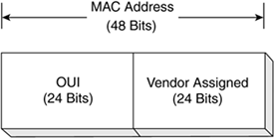

Let's take an example MAC address: C8:60:00:BA:95:65.

The first part, C8:60:00, is like the manufacturer ID. It tells you who made the device.

The second part, BA:95:65, is like the device ID. It's unique to each device made by that particular company, as the device's personal code.